 **Recruitment Exercise**

**SAP Product Support**

In this exercise you received a complete package, that contains required components with the instruction to build and start the following services:

* Apache – HTTP web server, expose [*http://recruitment.calculator.com*](http://recruitment.calculator.com)domainon default port. Virtual host connect with the Tomcat GUI endpoint via HTTP proxy on 8080 port. Configuration file can be found in folder: *./recruitment/apache/conf/calculator.conf.*
* Tomcat API – Calculator web-app, expose API on port 8081 with the URI /calculator/v1/calculate. Example API call to calculate VAT rate:   
  *curl 'http://localhost:8081/calculator/v1/calculate?vatRate=20&netAmount=200'*
* Tomcat GUI – Frontend web-app, expose service on default port 8080. Communicate with the API and display the results in a human readable form.
* README.md – Prerequisites and instructions to how to build and start the services.

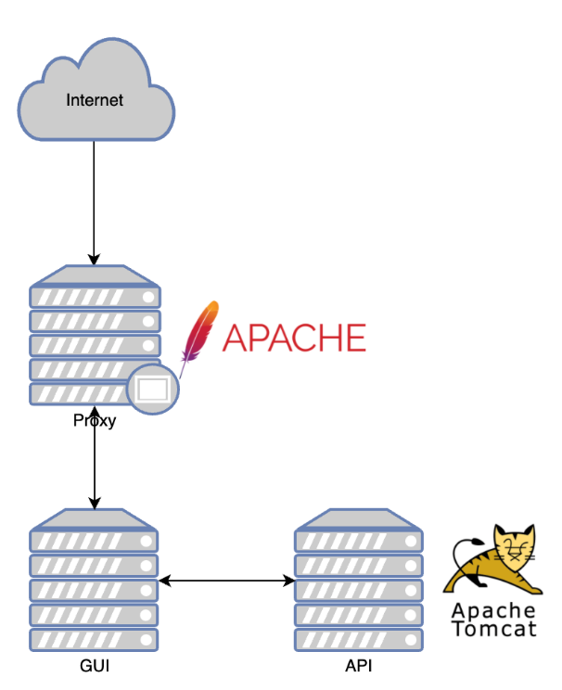

Your task is to fix the following issues:

1. Build error: File does not exist

When running the build script, following error appears:

*Step 4/7 : COPY conf/server.xml /usr/local/tomcat/conf/server.xml*

*COPY failed: stat /var/lib/docker/tmp/docker-builder751721554/conf/server.xml: no such file or directory*

#Hint

Review the whole package structure, make sure each file exist.

I created the file again

Sending build context to Docker daemon 20.48MB

Step 1/7 : FROM tomcat:8.0-alpine

---> 624fb61775c3

Step 2/7 : LABEL rekrutacja=tomcat

---> Using cache

---> 179028f147cb

Step 3/7 : ADD calculator.war /usr/local/tomcat/webapps/

---> Using cache

---> 549da534f8b8

Step 4/7 : COPY conf/server.xml /usr/local/tomcat/conf/server.xml

---> 0b7e32d3682f

Step 5/7 : COPY conf/web.xml /usr/local/tomcat/conf/web.xml

---> 9a91e29a9df8

Step 6/7 : EXPOSE 8081

---> Running in 16140c998192

Removing intermediate container 16140c998192

---> 8370f60b9fca

Step 7/7 : CMD ["catalina.sh", "run"]

---> Running in aa9059cd7a3b

Removing intermediate container aa9059cd7a3b

---> 5eafad17c835

Successfully built 5eafad17c835

Successfully tagged recruitment-tomcat-api:latest

Sending build context to Docker daemon 13.82kB

Step 1/6 : FROM tomcat:8-jre8

---> 254fc4a5cdb4

Step 2/6 : LABEL rekrutacja=tomcat

---> Using cache

---> 98b5e50e3487

Step 3/6 : RUN mkdir -p /usr/local/tomcat/webapps/calculatorgui

---> Using cache

---> 559d539cc285

Step 4/6 : COPY calculatorgui/index.html tomcat/webapps/calculatorgui/index.html

---> Using cache

---> ad830e80584b

Step 5/6 : EXPOSE 8080

---> Using cache

---> f55c5c12e512

Step 6/6 : CMD ["catalina.sh", "run"]

---> Using cache

---> 8a254c4150a1

Successfully built 8a254c4150a1

Successfully tagged recruitment-tomcat-gui:latest

1. Port already in use

When running the start script, following error appears:

*./start.sh*

*Creating calculator_tomcat-api_1 ...*

*Creating calculator_tomcat-api_1 ... error*

*ERROR: for calculator_tomcat-api_1 Cannot start service tomcat-api: driver failed programming external connectivity on endpoint calculator_tomcat-api_1 (46ab9ee9416cf71692a8bd81415b60dd8a8901a3b5166d5b0a4b73373ee5d4e7): Bind for 0.0.0.0:80 failed: port is already allocated*

*ERROR: for tomcat-api Cannot start service tomcat-api: driver failed programming external connectivity on endpoint calculator_tomcat-api_1 (46ab9ee9416cf71692a8bd81415b60dd8a8901a3b5166d5b0a4b73373ee5d4e7): Bind for 0.0.0.0:80 failed: port is already allocated*

*ERROR: Encountered errors while bringing up the project.*

#Hint

Make sure docker-compose.yml is properly configured.

1. Connection refused

When typing in the browser, following error appears:

*ERR_CONNECTION_REFUSED*

#Hint

Check the apache logs (`docker logs` command might help). Fix the Dockerfile configuration.

1. 503 error

When typing <http://recruitment.calculator.com/sap> in the browser, following error appears:

*Service Unavailable*

*The server is temporarily unable to service your request due to maintenance downtime or capacity problems. Please try again later.*

*Status Code:503 Service Unavailable*

#Hint

Review docker-compose.yml, make sure Apache use the correct port binding.

*`Docker-compose ps` command might help.*

1. 404 error

When typing <http://recruitment.calculator.com/sap> in the browser, following error appears:

*HTTP Status 404 – Not Found*

*Type Status Report*

*Message The requested resource [/calculatorgui/] is not available*

*Description The origin server did not find a current representation for the target resource or is not willing to disclose that one exists.*

*Apache Tomcat/8.5.71*

#Hint

Review the GUI Dockerfile.

1. Tomcat-Api Unsupported major.minor version

When calculating the data, following error appears:

GET http://localhost:81/calculator/v1/calculate?vatRate=13&netAmount=31 404 (Not Found)

#Hint

Review the application logs. Make sure the correct image is being used.

1. *Apache 403 error*

When typing <http://recruitment.calculator.com/> in the browser, following error appears:

*Forbidden*

*You don't have permission to access this resource.*

#Hint

Review the permissions.

1. Adjust the Apache config, so the calculator will be accessible via <http://recruitment.calculator.com/> URL without /sap URI. All the other resources should display a default page.

Open questions:

What would you improve in the recruitment-calculator architecture?

What kind of mistakes / security gaps (beside the above ones) did you notice?